1St Annual
Bellevue Heights UMC – Syracuse
And
Robinson Memorial Presbyterian
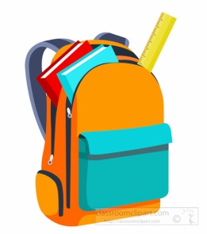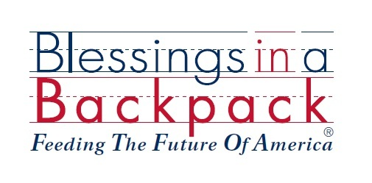
Charity Golf Tournament
Tee up with us to raise awareness and money to support our Blessings in a Backpack program for providing nourishment over the weekends for students of Delaware School during the school year.
There will be prizes, on course games, and raffles
When: Sunday August 13, 2017
Time: 1pm shotgun start – dinner to follow
Where: Foxfire at Village Green
FEE: $100 per golfer
Contact Steve Mattice at smattice62@gmail.com for registration information+

All proceeds after expenses go directly to Blessings in a backpack to support our mission of feeding hungry students at Delaware school in Syracuse, NY.
1St Annual
Bellevue Heights UMC – Syracuse
And
Robinson Memorial Presbyterian
Charity Golf Tournament
_________________________________________________________________________________
Please send the completed entry form by AUGUST 6, 2017 to:
Steve Mattice
C/O Bellevue Heights UMC
2112 South Geddes Street
Syracuse, NY 13207

Make checks payable to BHUMC and mark it for BIBP Golf in the memo
Entry Form
FOURSOME:
Team Name____________________________(optional)
Captain*:________________________________ $100
Crew 1*:_________________________________ $100
Crew 2*:_________________________________ $100
Crew 3*:_________________________________ $100
Captain’s Email*:_________________________________ Phone*:__________________

Individual:
Name*:__________________________________ $100
Email*:__________________________________ Phone*:_________________
Tournament Use
PD: AMT_________ $ 
DR: ________2017
SG: Y N
M W MX

Dinner Only:
Name*:__________________________________ $45
Email*:__________________________________ Phone*:_________________
Total Enclosed: $_________
*-Required information fields

